**azek – crown moulding**

Crown moulding profiles are typically decorative mouldings designed for use along the intersection of a wall or ceiling. May be combined with other mouldings to create a built-up profile.

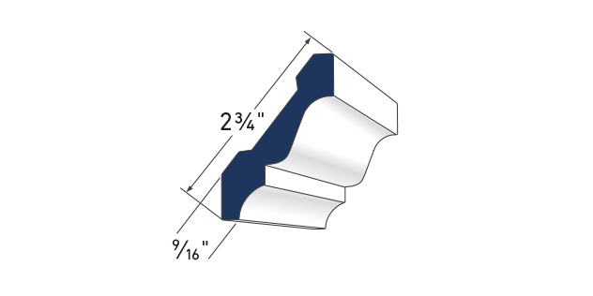

**3" Crown**AZM–52

**LENGTH: 16′**

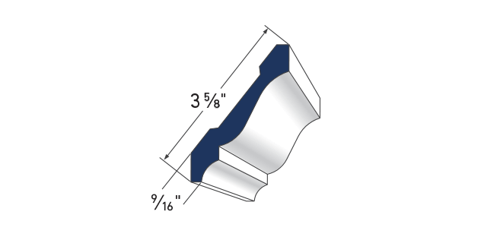

**4" Crown**AZM–49

**LENGTH: 16′**

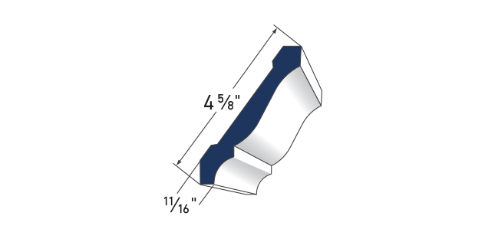

**5" Crown**AZM–47

**LENGTH: 16′**

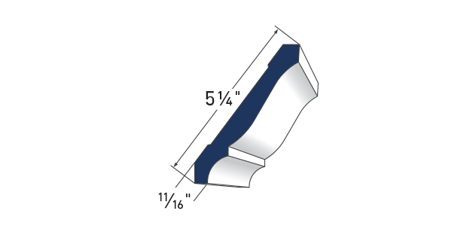

**6" Crown**AZM–45

**LENGTH: 16′**

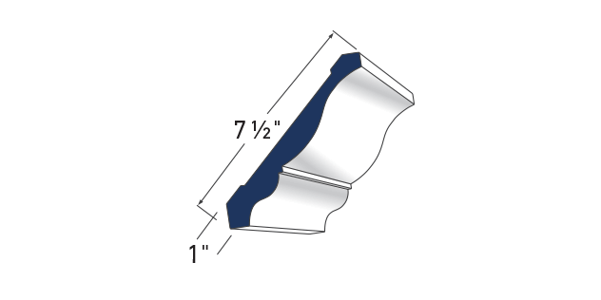

**8" Crown**AZM–43

**LENGTH: 16′**

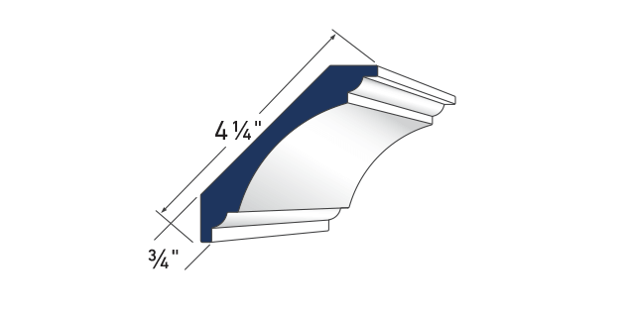

**Cove Moulding**AZM–80

**LENGTH: 16′**

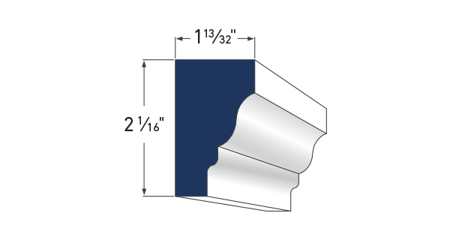

**Rams Crown**AZM–6934

**LENGTH: 16′**

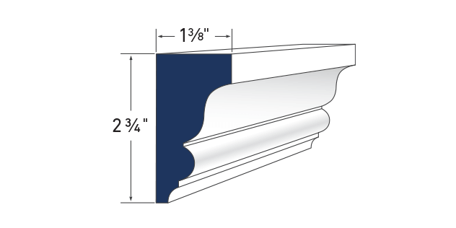

**Imperial Rake Crown**AZM–6937

**LENGTH: 16′**

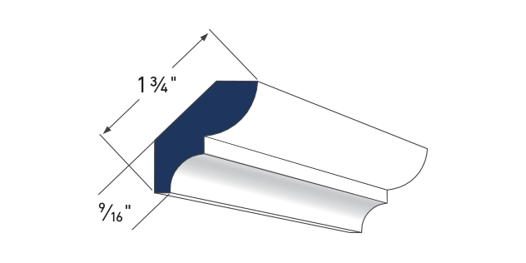

**Bed Moulding**AZM–75

**LENGTH: 16′**

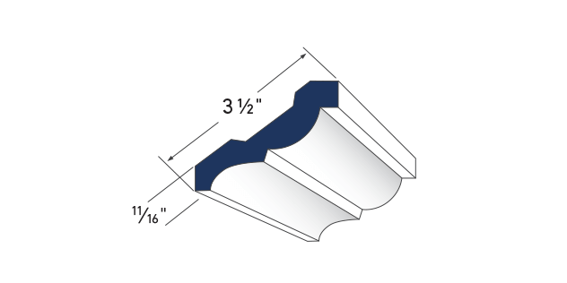

**3 1/2" Bed Moulding**AZM–28

**LENGTH: 16′**

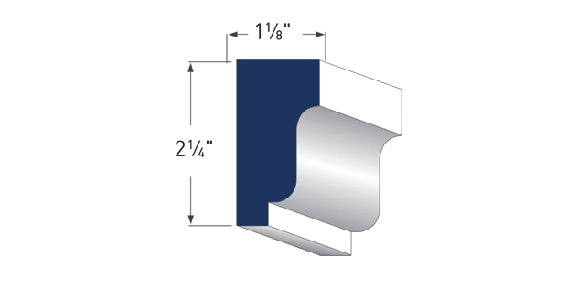

**Solid Crown**AZM–7954

**LENGTH: 16′**

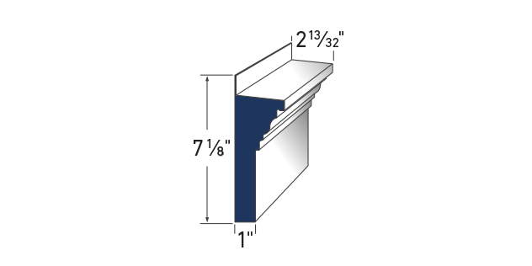

**Crosshead Pediment**AZM–6216

**LENGTH: 18′**